Rebel Messenger Service
Software Architecture Document

Version 1.1 – Elaboration Milestone

Revision History
Date | Version | Description | Author
26 November, 2010 | 1.0 | Initial SDD | Beauchamp, Samuel  Carter, Greg  Conradi, Jeff  Le, Tri  Roberts, Gary  Thomas, Rainee  Uzowihe, Kenna  Watkins, Charles
04 December, 2010 | 1.1 | Complete SDD | Beauchamp, Samuel  Carter, Greg  Conradi, Jeff  Le, Tri  Roberts, Gary  Thomas, Rainee  Uzowihe, Kenna  Watkins, Charles

Table of Contents
1. Introduction 4
1.1 Purpose 4
1.2 Scope 4
1.3 Definitions, Acronyms, and Abbreviations 4
1.4 References 4
1.5 Overview 4
2. Architectural Representation 5
3. Architectural Goals and Constraints 5
4. Use-Case View 5
4.1 User Interfaces 6
4.2 System Inputs and Outputs 8
4.2.1 Inputs 8
4.2.2 Outputs 8
4.3 Use-Case Realizations 8
4.3.1 Risk ranking of Use Cases 8
4.3.2 Use Case Diagram 8
4.3.3 Use Case Descriptions 9
4.3.4 State Chart Diagram 9

5. Logical View 11
5.1 Overview 11
5.2 Architecturally Significant Class Specifications 11
5.3 Risk Rank of classes 16
5.4 Sequence Diagram 17
5.5 Collaboration Diagram 19

6. Performance 20
7. Quality 20

Software Architecture Document

Introduction

Purpose
The purpose of this document is to collect, analyze, and define high-level needs and features of the Rebel Messenger service for UNLV students. It focuses on the capabilities needed by the Rebel Messenger users. The details of how the Rebel Messenger system fulfills these needs are provided in the Software Requirements Specification.

Scope
The Rebel Messenger client software will be installed and used on individual user PCs. The server software that will connect clients will be installed and used on a single machine. The server will be designed to be used by the system administrators from a dedicated server. The Server has been written to be infinitely scalable and able to accommodate multiple infrastructure configurations for the service. Both the server and client will use the TCP Protocol.

The Rebel Messenger system will enable the users to register for an account, log in, send friend requests, reject friend requests, send messages, receive messages, the saving of a buddy list, viewing of the buddy list, request new user password, and log out of the client.

The Rebel Messenger system will enable the administrators to log in, send messages, receive messages, view buddy list, confirm user requests, delete accounts, reset passwords, query users, broadcast announcements, and log out.

Definitions, Acronyms, and Abbreviations
(UNLV) – University of Nevada, Las Vegas

(TCP) Transmission Control Protocol – An internet protocol that uses retransmission to ensure all data is received. This choice is ideal over other less reliable protocols for smaller transmissions that require reliability.

(IM) Instant Messaging - A form of real-time direct text-based communication between two or more people using personal computers or other devices. The user's text is conveyed over a network, such as the Internet.

References
None.

Overview
Rebel Messenger provides online instant messaging to any student enrolled at the University of Nevada at Las Vegas. The Rebel Messenger service offers an online community for users to participate in instant messaging and general online chatting services. Each student of UNLV will have access to a Rebel Messenger account free of charge. The software will also be scalable to meet the needs of individual departments within the UNLV network, allowing departments to have private chat servers that are independent from the UNLV general Rebel Messenger server for the departments use.

The remainder of this Vision document will identify Product Features, Other Product Requirements and Documentation Requirements.

Architectural Representation
Figure 1 Architectural diagram of the product

Architectural Goals and Constraints
The “Rebel Messaging System” server software will run on a dedicated platform with access to the internet, and an SQL database. The client will run as a standard service on any Windows PC, and the machine must have access to the internet. Both the client and the server will also be connected to some form of standard graphical output (monitor), and some way of receiving standard input (keyboard). Neither of these has to be physical connections to devices. In fact, the server should ideally be network-accessible through some remote connection to the shell.

The SQL database will be used to store and manage user credentials and buddy records. All other information will be stored in local main memory without the aid of the database interface.

The program is currently implemented for any NT-based Windows OS, but it can be ported to Linux and Mac-based systems in the future.

Use-Case View

User Interfaces
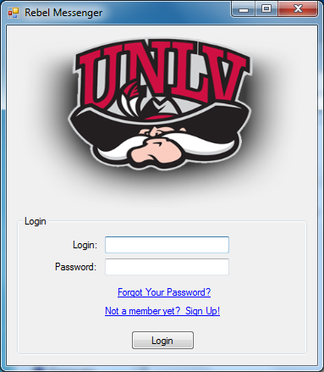
Figure 2 Initial screen
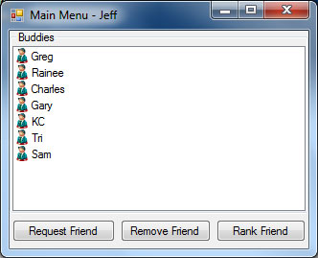
Figure 3 Screen when a client/user logs in
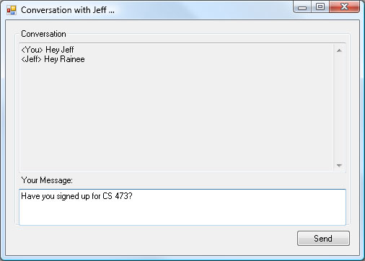
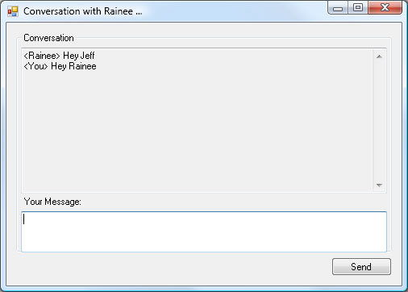

Figure 4 Screen when a message is sent to another client/user

System Inputs and Outputs

Inputs
User Input – input from the user shall be provided via the keyboard and the mouse

Outputs
Graphical – output from the program shall be displayed via the standard output, typically the user's monitor.
Database – user account changes, transactions, and other information shall be stored within the database of Rebel Messenger.

Use-Case Realizations

Risk ranking of Use Cases
Use Case Risk list is ranked from the highest to the lowest risk use case.

Use Case Risk List
High | Manage User Accounts  Manage Buddy List
Moderate | Handle Messages  Register accounts
Low | Broadcast Message  Request New Password  Log In / Log Out

Use Case Diagram

Figure 5 Use Case Diagram

4.3.3 Use Cases Descriptions

- Login/Logout
- Details the process by which the user is able to create and destroy his or her session to the Rebel Messenger server
- Manage Buddy List
- Details the process by which the user is able to add, remove, and rank buddies
- Handle Messages
- Details the process by which the user is able to send and receive messages from users on his or her buddy list
- Register Account
- Details the process by which the user first creates his or her account on the Rebel Messenger service
- Request New Password
- Details the process by which the user is able to request his or her password to be reset by an administrator
- Manage User Accounts
- Details the process by which an administrator is able to perform managerial tasks on registered users, such as listing and resetting their passwords
- Broadcast Announcements
- Details the process by which an administrator is able to send a message to all currently logged in users and administrators

4.3.4 State Chart Diagrams

Figure 6 State chart showing the dynamic behavior of the Manage User Accounts use case

Figure 7 State chart showing the dynamic behavior of the Manage Buddy List use case

Logical View

Overview
Figure 8 Class diagram

Architecturally Significant Class Specifications

5.2.1 Initialization Class

Brief Description
A control class which will load all the required components into memory during the execution lifetime of the RebelMessenger program
CLASS | A/M |  | Type | Name | Description
intializationClass |  |  |  |  | This method is used for initialization.

User Class

Brief Description

An entity acting as a virtual class that will be invoked by either the client and admin class in the RebelMessenger application. This class will hold the majority of attributes associated with the two levels of user, both a standard client and administrator.

CLASS | A/M | Type | Name | Description
User
 | M | Void | user | This method is the constructor for the user class.
 | M | Void | ~user | This method is the destructor for the user class.
 | M | Void | sendMessage | This method is used to sending message to other users
 | M | Void | recvMessage | This method is used receive message from other users
 | M | Void | saveConvs | This method saves a conversation to a conversation record
 | A | String | firstName | This attribute is the first name of the user.
 | A | String | lastName | This attribute is the last name of the user.
 | A | String | handle | This attribute is the user’s identification or nickname
 | A | String | RebelMail | This attribute is the user’s RebelMail address, required for registration
 | A | String | Password | This attribute is the password of the user
 | A | Int | Standing | This enumerated integer describes the users standing within the university

Client Class

Brief Description

An entity class inherited from the user class. This class represents a standard user with extended method such as friend request, register account and requesting and updating their personal password

CLASS | A/M | Type | Name | Description
Client
 | M | Void | client | This method is the constructor the client class.
 | M | Void | ~client | This method is the destructor of the client class.
 | M | Void | friendRequest | This method is used to request another client to become friends
 | M | Void | registerAccount | This method complies information of user for a new account creation
 | M | Void | requestPasswd | This method
 | M | Void | changePasswd | This method will allow a client to set a personalized password once a default password has been issued by an admin

Admin Class

Brief Description

An entity class inherited from the user class. This class represents an administrative user with extended method such broadcast message to all user on the system.

CLASS | A/M | Type | Name | Description
Admin
 | M | Void | admin | This method is the constructor the administrator class.
 | M | Void | ~admin | This method is the destructor of the administrator class.
 | M | Void | broadcastMsg | This method allows an admin to send messages to every client for system announcements

Database Class

Brief Description

A boundary class, the database will stores all the records involved in the application. Records such a userRecord, buddyRecord, and convsRecord will all be held within the database class, and any time data is stored or fetched from the database will be handled within this class.

CLASS | A/M | Type | Name | Description
Database
 | M | Void | database | This method is the constructor of the database class
 | M | Void | ~database | This method is the destructor of the database class
 | M | Void | getUser | This method returns a user record from the database
 | M | Void | updateUser | This method updates a user record to the database
 | M | Void | getBuddy | This method returns a buddy record from the database
 | M | Void | updateBuddy | This method updates a buddy record to the database
 | M | Void | getConvs | This method returns a conversation record from the database
 | M | Void | deleteConvs | This method removes a conversation record from the database
 | M | Void | updatePasswd | This method assigns a new password to a user

BuddyRecord Class

Brief Description

This entity class is responsible storing data associated with a user’s buddy.
CLASS | A/M | Type | Name | Description
buddyRecord
 | M | Void | buddyRecord | This method is the constructor of the buddyRecord
 | M | Void | ~buddyRecord | This method is the destructor of the buddyRecord
 | A | client | buddyName | This client attribute stores the information of the buddy held within the record
 | A | Int | friendRank | This attribute stores the rank of the buddy within a clients buddy list

ConvsRecord Class

Brief Description

This entity class stores a conversation if one is saved by a user, if desired
CLASS | A/M | Type | Name | Description
convsRecord
 | M | Void | convsRecord | This method is the constructor of the convsRecord
 | M | Void | ~convsRecord | This method is the destructor of the convsRecord
 | A | String* | convs | This string pointer references the conversation buffer
 | A | Date | timeStamp | This date attribute stores the time and date when the conversation was saved
 | A | client | hostClient | This attribute references the client which initiated the conversation
 | A | client | guestClient | This attribute references the client that accepted the conversation

UserRecord Class

Brief Description
An entity class which contains information associated with registered users on the Rebel Messenger network.
CLASS | A/M | Type | Name | Description
userRecord
 | M | Void | userRecord | This method is the constructor of the userRecord
 | M | Void | ~userRecord | This method is the destructor of the userRecord
 | M | Void | isAdmin | This method checks is the user within the record is an administrator
 | A | User | userName | This attribute stores a users data, either client or administrator
 | A | Date | lastOnline | This attribute holds the date in which was last online
 | A | Boolean | isAdmin | This attribute is a Boolean flag that determines if a user is a client or administrator

Control Class

Brief Description
A control class that handles the flow of requests and input from the user provided through the interface class.
CLASS | A/M | Type | Name | Description
controlClass
 | M | Void | controlClass | This method is the constructor of the controlClass.
 | M | Void | ~controlClass | This method is the destructor of the controlClass.
 | M | Void | registerAccount | This method will allow a new client to register an account
 | M | Void | sendMessage | This method allows a user send message
 | M | Void | receiveMessage | This method accepts a new message to establish a conversation between users
 | M | Void | updateFriends | This method will update user’s buddy list and set rankings onto each buddy
 | M | Void | requestPassword | This method will request a new password to be issued to a client
 | M | Void | friendRequest | This method allows a client to request a new friend to be added to buddy list
 | M | Void | deleteFriend | This method removes a client from ones buddy list
 | M | Void | saveConvs | This method saves a conversation with another user into a convsRecord
 | M | Void | changePassword | This method allows a user to change their password
 | M | Void | registerAccount | This method will allow a new client to register an account
 | M | Void | sendMessage | This method allows a user send message
 | M | Void | verifyLogin | This method verifies login.

Interface Class

Brief Description
A boundary class that represents the visual components connecting the user to the application and system components.
CLASS | A/M | Type | Name | Description
interfaceClass | M | Void | interfaceClass | This method is the constructor of the interfaceClass.
 | M | Void | ~interfaceClass | This method is the destructor of the interfaceClass.
 | M | Void | registerAccount | This method will allow a new client to register an account
 | M | Void | sendMessage | This method allows a user send message
 | M | Void | receiveMessage | This method accepts a new message to establish a conversation between users
 | M | Void | updateFriends | This method will update user’s buddy list and set rankings onto each buddy
 | M | Void | requestPassword | This method will request a new password to be issued to a client
 | M | Void | friendRequest | This method allows a client to request a new friend to be added to buddy list
 | M | Void | deleteFriend | This method removes a client from ones buddy list
 | M | Void | saveConvs | This method saves a conversation with another user into a convsRecord
 | M | Void | changePassword | This method allows a user to change their password
 | M | Void | login | This method allows login.
 | M | Void | logout | This method allows logout.
Table 1 Classes (A/M indicates Attribute or Method, with capital letters indicating Public)

Risk Rank of classes
Class Risk list is ranked from the highest to the lowest risk class.

userRecord | Highest
user
buddyRecord
interfaceClass
controlClass
database
convsRecord
admin
client | Lowest

Sequence Diagrams

Figure 9 Sequence Diagram of Manage User Accounts Use Case
Figure 10 Sequence Diagram of Manage Buddy List Use Case

Collaboration Diagram

Figure 11 Collaboration Diagram of Manage User Accounts Use Case

Figure 12 Collaboration Diagram of Manage Buddy List Use Case

Performance
Performance of the messenger will be highly dependent on the network latency, to maintain high performance standards across reliable networks, the system has been designed to limit messages to 16kb. The system will require a Windows NT or higher to allow for .net framework.

Quality
The quality of the product will meet the standard for basic IM services. Given proper hardware conditions and a reliable network connection users should get the sense the message is received instantly.

